**National WIC Association**

**Farmers Market Nutrition Program**

**Organic Social Media Content 2023**

This content will be used to promote the Farmers Market Nutrition Program and will be posted on the WIC You Got This Facebook and Instagram pages. Agencies can use as much of this content on their own pages, as well. As always, if these dates don’t work in your posting schedule, feel free to adjust them in your own calendars by a couple of days.

***Organic Social Media Posts – Facebook and Instagram***

**June**

**Post 1 – June 5**

**Copy**: It’s farmers market season, WIC fam! Get your benefits at your closest WIC agency and use them on locally grown produce at the farmers market.

Remember, these are in addition to your regular monthly WIC benefits 🥳

Haven’t signed up for WIC yet? Visit [www.signupwic.com](https://signupwic.com) to learn more! 💜 #HealthyStartsHere

**Creative Option 1-Checks Imagery**:

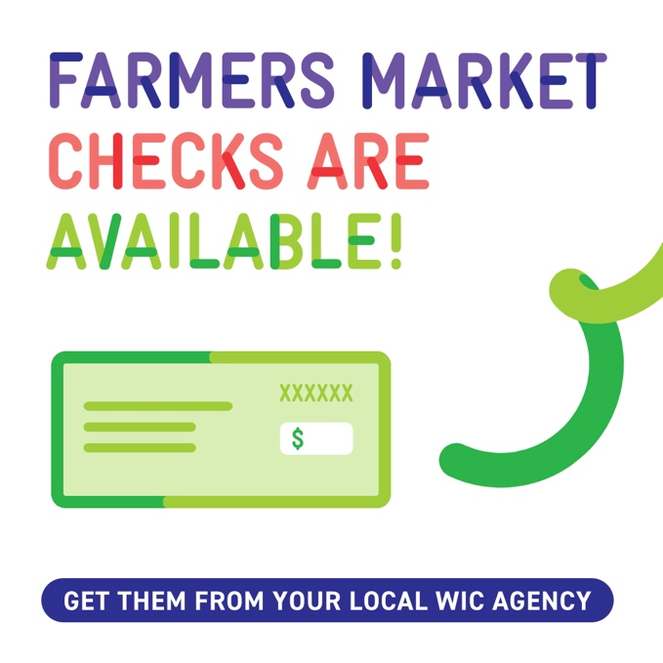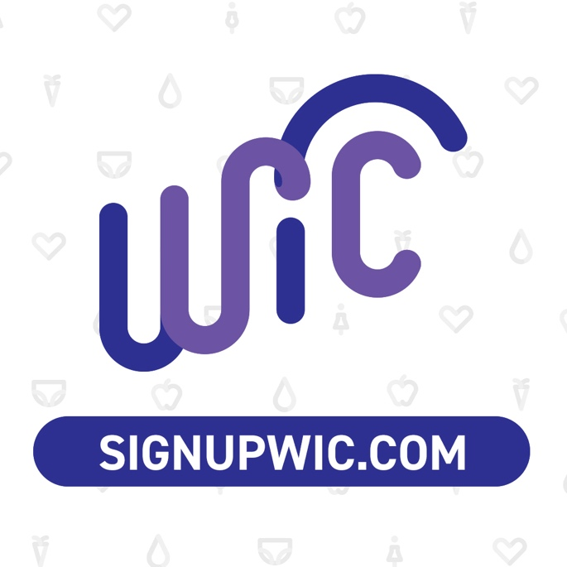

**Creative option 2-EBT Imagery**:

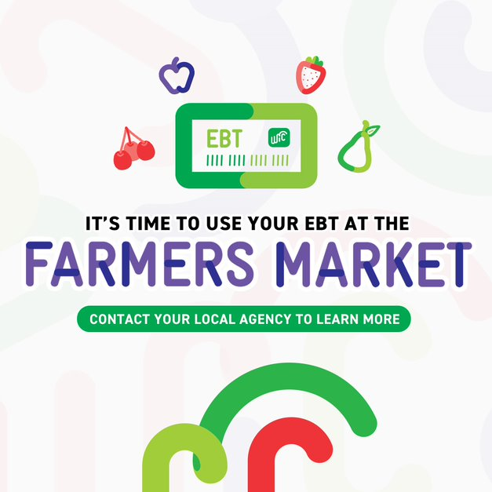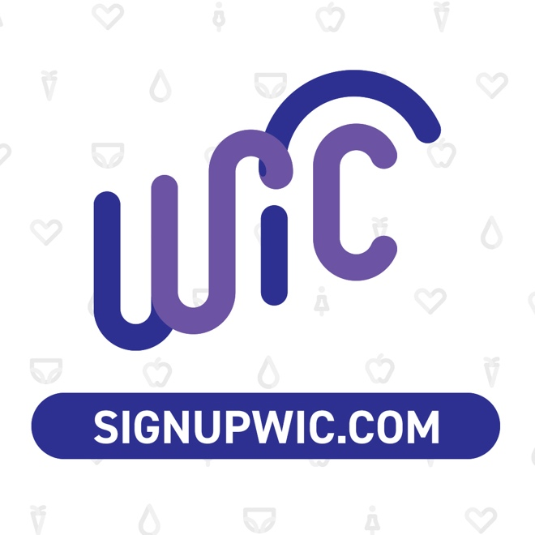

**Post 2 – June 13**

**Copy**: Shopping at the farmers market with your little ones can be a fun experience! They can learn about local fruits and veggies in an open-air environment and be exposed to new sights, sounds, and smells.

Talk to your local WIC agency about the Farmers Market Nutrition Program!

Visit [signupwic.com](https://signupwic.com/) to learn more. 🍎🥒🌽 #HealthyStartsHere

**Creative:**

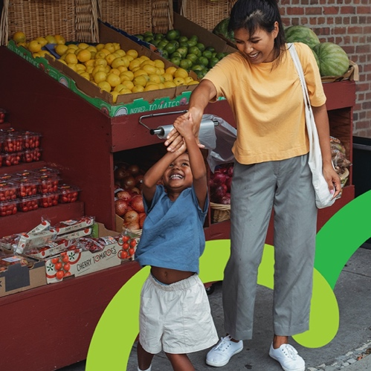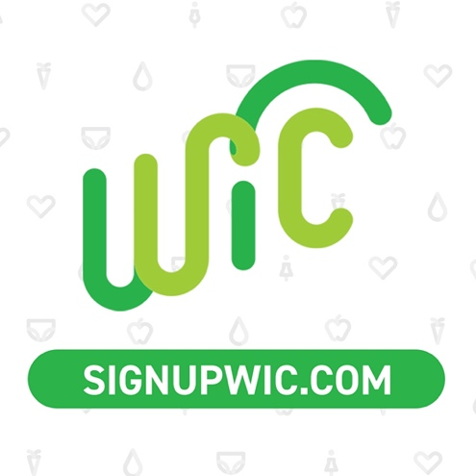

**Post 3 – June 22**

**Copy**: Not sure what you can purchase using your Farmers Market Nutrition Program (FMNP) checks or EBT card? Your local WIC agency and the farmers who accept FMNP benefits can help you! 🧑‍🌾

Find your local agency at [signupwic.com](https://signupwic.com/.) #HealthyStartsHere

**Creative**:

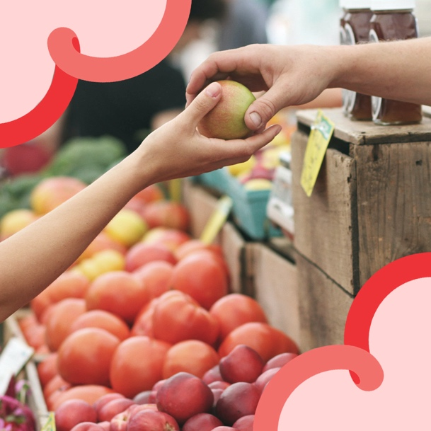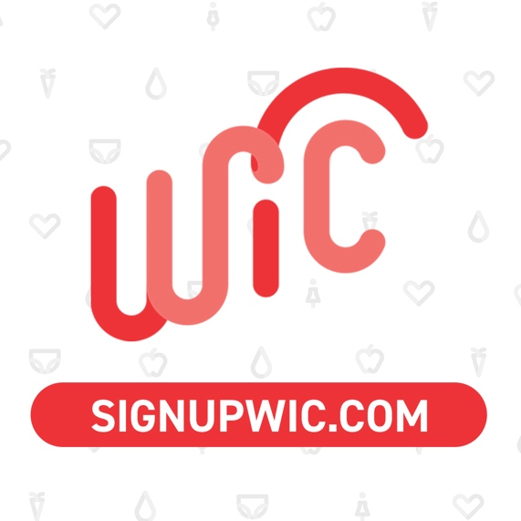

**July**

**Post 4 – July 6**

**Copy**: July means berries are in season 😋 Use your Farmers Market Nutrition Program (FMNP) checks or EBT card at the market or at a pick your own berries farm! 🫐🍓🍒

Your local agency can give you your FMNP benefits – find yours at [signupwic.com](https://signupwic.com/.) #HealthyStartsHere

**Creative**:

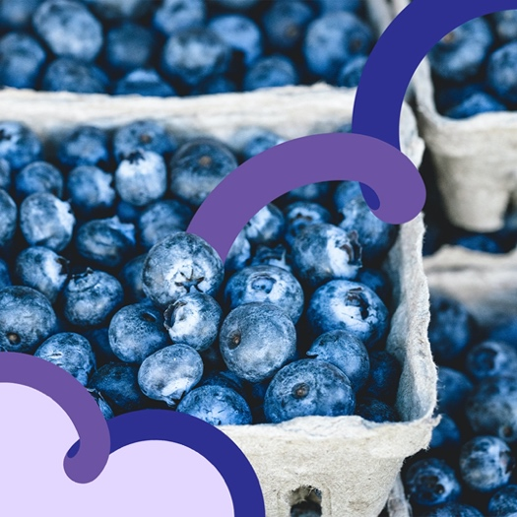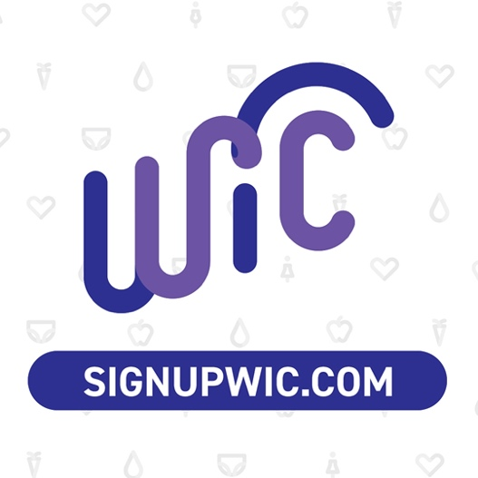

**Post 5 – July 19**

**Copy**: Making a smoothie, salad, pasta, or other meal? Add some fresh, local produce! You can use your Farmers Market Nutrition Program (FMNP) benefits to purchase locally grown food at the market.

Find your local agency at [signupwic.com](https://signupwic.com/.) #HealthyStartsHere

**Creative**:

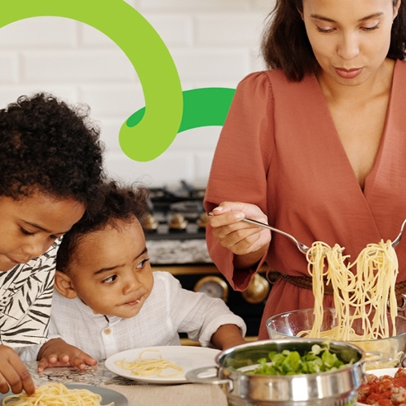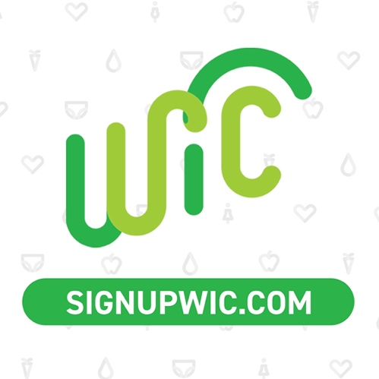

**August**

**Post 6 - August 8**

**Copy**: Not only are farmers markets fun, but they also help support local farmers! You can purchase local fruits, veggies, and other foods at the market using your Farmers Market Nutrition Program (FMNP) benefits. They expire at the end of October, so make sure to use them while you can!

Your local agency can give you your FMNP benefits– find yours at [signupwic.com](https://signupwic.com/.) #HealthyStartsHere

**Creative**:

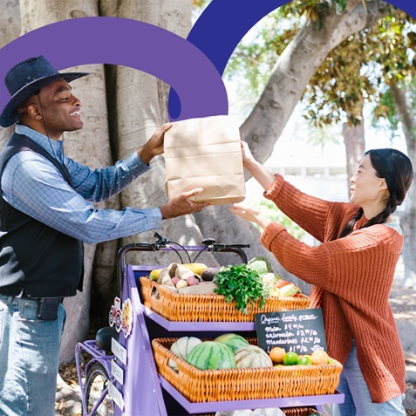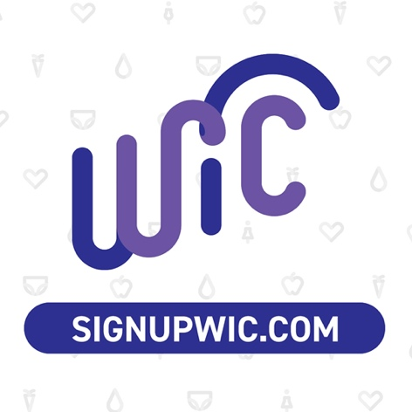

**Post 7 - August 24**

**Copy**: What are some benefits of visiting your local farmers market?

Get produce while it’s fresh 🌱

Support local farmers 💚

Use your Farmers Market Nutrition Program (FMNP) benefits to purchase fruits & veggies 😋

Find your local WIC agency at [signupwic.com](https://signupwic.com/.) #HealthyStartsHere

**Creative**:

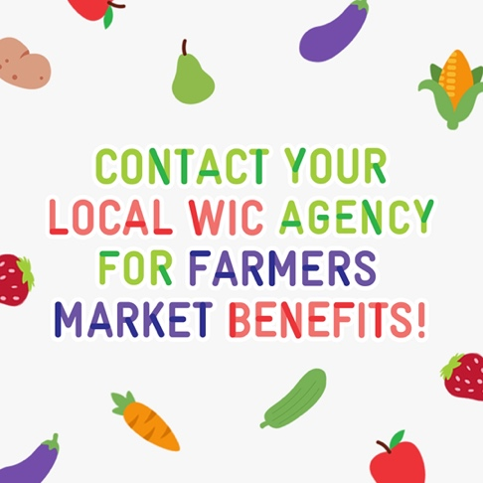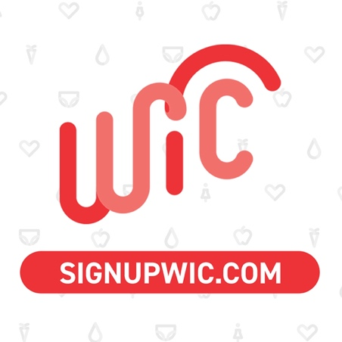

**September**

**Post 8 – September 13**

**Copy**: Visiting the farmers market with your little one? Here are some tips for keeping them engaged and happy 😄

🌱 Give your child a copy of your list, so they can help you search for items.

🌱 Come prepared with a snack your child can eat, since they’ll be surrounded by food and may get hungry.

🌱 Ask your child to point out new fruits and veggies they’re unfamiliar with – they may learn something new!

Don’t forget to reach out to your local WIC agency to get your Farmers Market Nutrition Program benefits! [signupwic.com](https://signupwic.com/) #HealthyStartsHere

**Creative**:

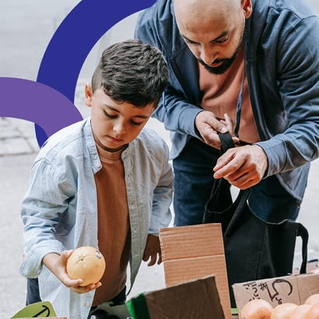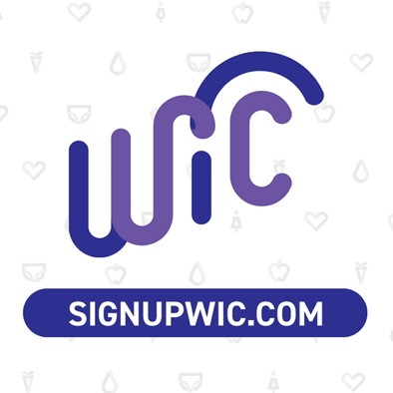

**Post 9 – September 26**

**Copy**: Welcome, fall! There’s still lots of tasty produce you can purchase at your local market using your Farmers Market Nutrition Program (FMNP) benefits!

What’s your favorite fall fruit or veggie? Drop yours in the comments! ⬇️

Find your local WIC agency here: [signupwic.com](https://signupwic.com/) #HealthyStartsHere

**Creative**:

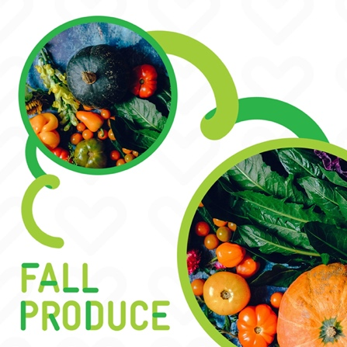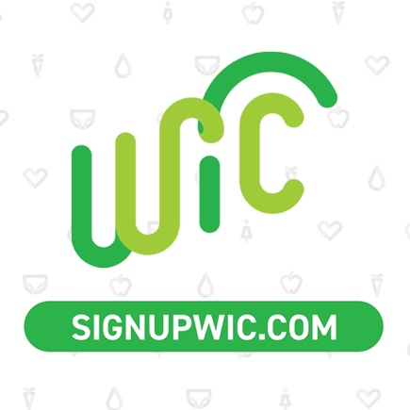

**October**

**Post 10 – October 10**

**Copy**: Don't miss out on the opportunity to enjoy fresh and delicious produce from your local farmers market! Get apples, bell peppers, squash, and other fall fruits and veggies for your little one 😋

Use your farmers market benefits from WIC by the end of the month – your local agency can get you set up with them!

Find your local agency: [signupwic.com](https://signupwic.com/) #HealthyStartsHere

**Creative**:

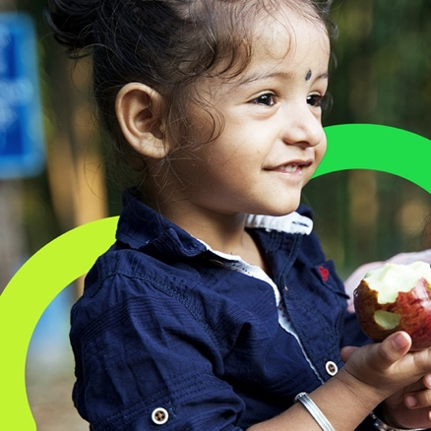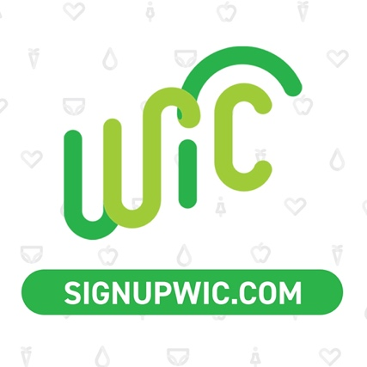

**Post 11 – October 23**

**Copy**: October is almost over – don’t forget to use all your Farmers Market Nutrition Program (FMNP) benefits! They’ll expire at the end of the month.

You can use these benefits to purchase local fruits and veggies. Ask your local agency for more info!

Find the closest WIC agency to you at [signupwic.com](https://signupwic.com/.) #HealthyStartsHere

**Creative**:

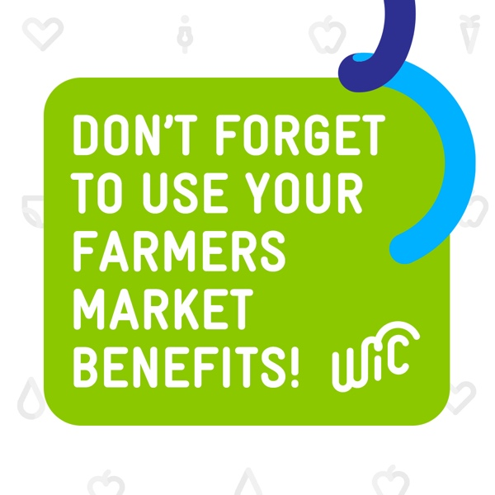

*This post can be altered by agencies to fit their needs and be specific to their geographic location:*

**Post 12 – Any time from June through October**

**Copy**: Not sure which fruits and veggies are currently at the farmers market? Check these out!

Reach out to your local agency for more information and to get your farmers market benefits: [signupwic.com](https://signupwic.com/.) #HealthyStartsHere

**Creative**:

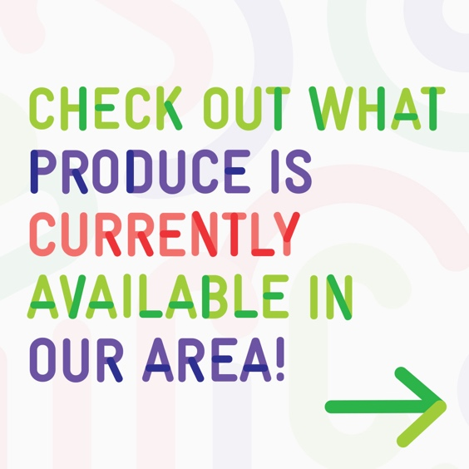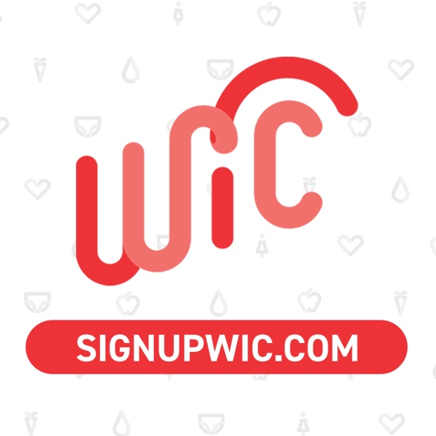

*Note: This graphic can be paired with a photo from a local market when posting on Facebook or Instagram, to make it specific to local produce. This isn’t imperative, only optional if you’d like to make the post reflective of the local area.*