Organic Social Media Content 1

Indigenous & Native American Content 8

Spanish National WIC Association 11

**National WIC Association**

# **Organic Social Media Content**

**Note:** These posting dates are recommended, not required. Agencies can post on any other preferred day.

**Facebook and Instagram:**

6 posts per month

Indigenous and Spanish calendars to come separately

**TikTok:**

6 posts per month

2–4 of the TikTok videos will have on-screen text that has been translated into Spanish, in order to reach more of the Spanish-speaking audience.

TikTok videos will also be shared on Instagram Reels.

**Indigenous:**

5 posts per month (2 will be posted on main NWA pages)

**English / WIC You Got This Pages**

**Facebook and Instagram**

***Post 1 – July 3***

**Copy**: Today is National Eat Your Beans Day! Beans can be added to so many meals, from tacos to wraps, and even to desserts like brownies!

You can use your WIC benefits to purchase pinto, black, red, kidney, white, and many more types of beans! Check with your local agency for a full list. 🫘

Visit [signupwic.com](http://www.signupwic.com) to find a WIC agency near you! #HealthyStartsHere

**Creative**:

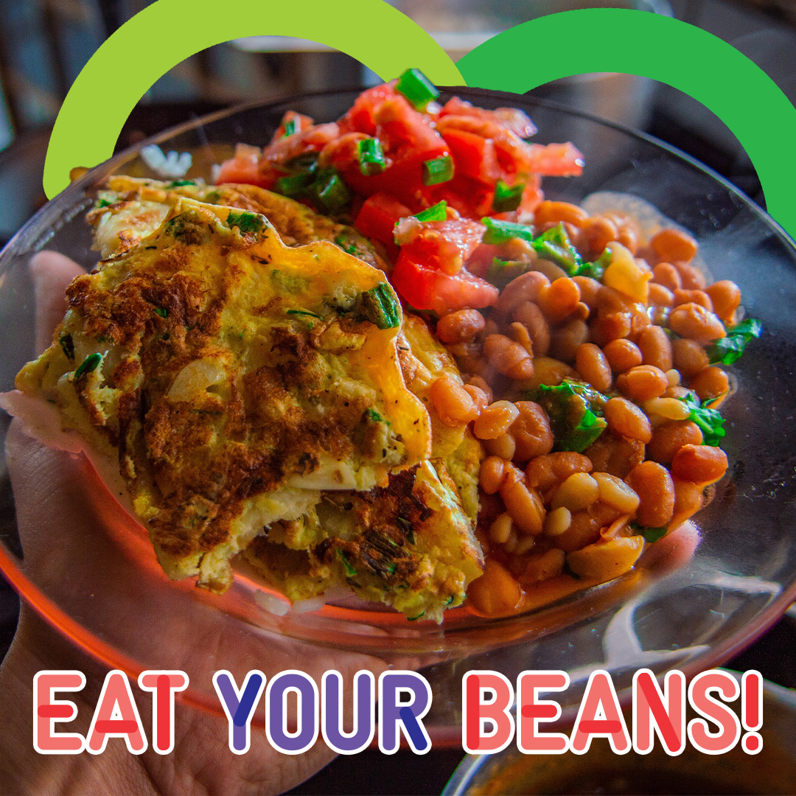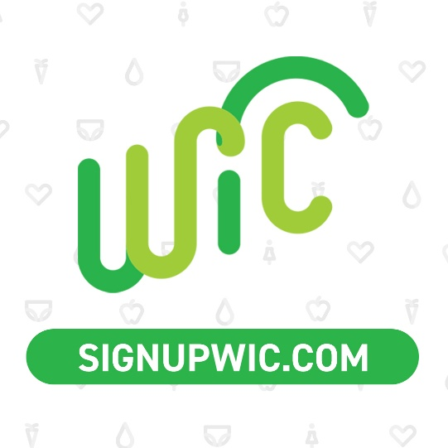

***Post 2 – July 6***

**Copy**: July is Disability Pride Month, and at WIC, we’re proud to serve parents and little ones with different abilities.

Visit [signupwic.com](http://www.signupwic.com/) to find your closest WIC agency, and to learn more about WIC benefits. #HealthyStartsHere

**Creative**:

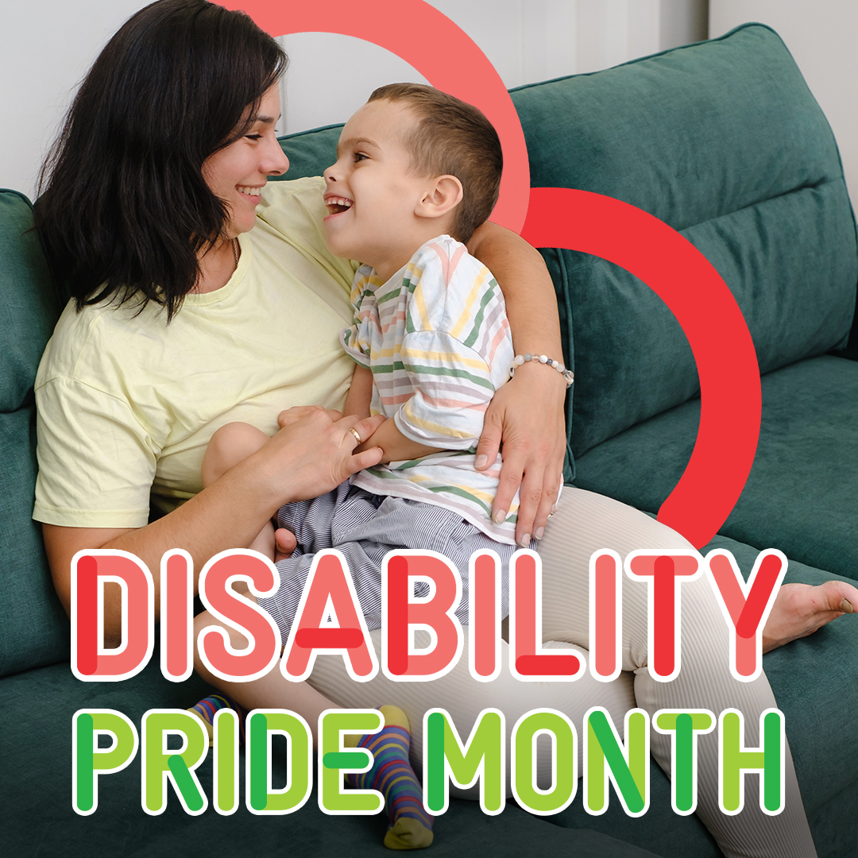

***Post 3 – July 11***

**Copy**: July is National Mango and Melon Month! You can purchase mango, watermelon, cantaloupe, and other types of melon with your WIC benefits. You can even use your farmers market checks at certain farmers’ markets to purchase melons!

Visit [signupwic.com](http://www.signupwic.com/) to find a WIC agency near you! #HealthyStartsHere

**Creative**:

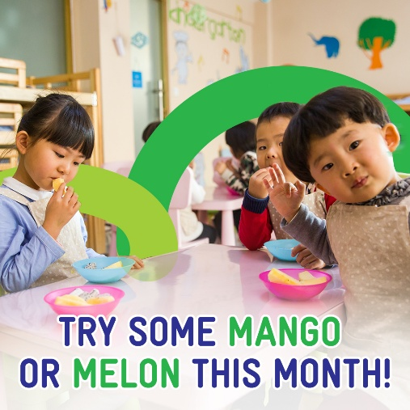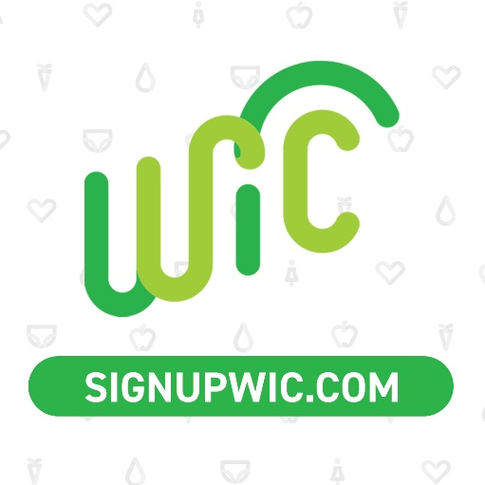

***Post 4 – July 19***

**Copy**: During National Minority Mental Health Awareness Month and all year long, we raise awareness of the barriers and struggles minority families face when it comes to their mental health. WIC is here to support you with access to mental health resources and referrals. Together, we can reduce the stigma of mental health struggles and help minority families access the resources they need to thrive.

Learn more about WIC benefits and how you can apply at [signupwic.com](http://www.signupwic.com/.) #HealthyStartsHere

**Creative**:

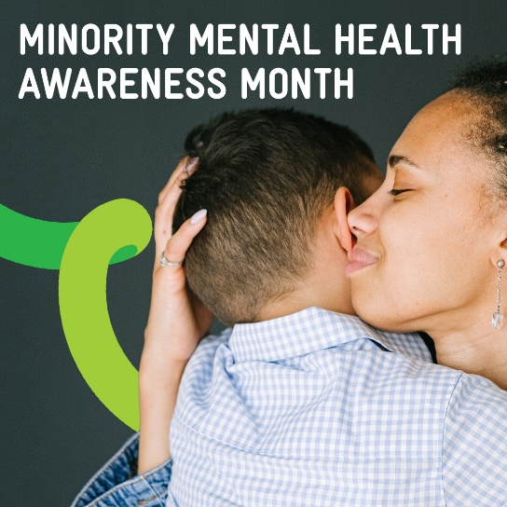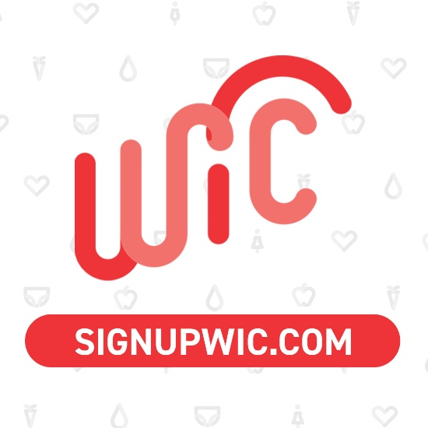

***Post 5 – July 23***

**Copy**: At WIC, every day is National Parents Day! Here’s to you and all you’re doing for your little ones – we’re here to support you with nutritious food, meal planning, recipes, health resources, and more ❤️

Visit [signupwic.com](http://www.signupwic.com/) to find a WIC agency near you. #HealthyStartsHere

**Creative**:

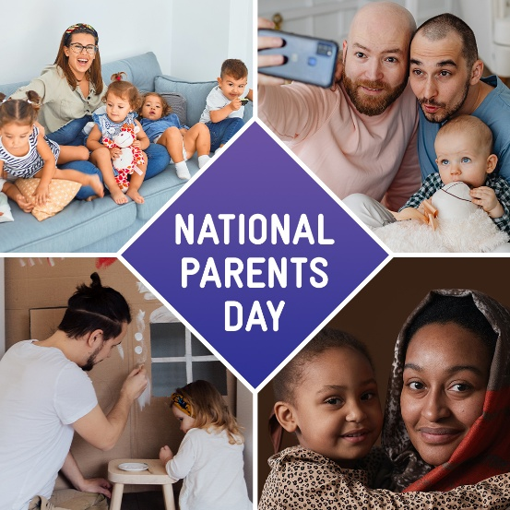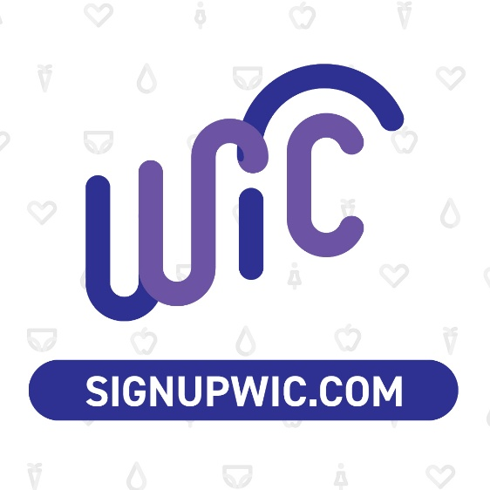

***Post 6 – July 31***

**Copy**: Happy National Avocado Day from WIC! 🥑 Add avocados to your little one’s toast, smoothies, sandwiches, and other meals for some extra fiber and fats, which your child needs in their diet. Pick some up today with your WIC benefits!

Find your local agency at [signupwic.com](http://www.signupwic.com/) #HealthyStartsHere

**Creative**:

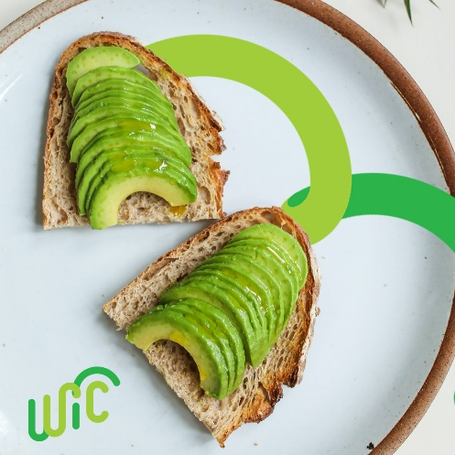

**TikTok and Instagram Reels**

***Post 1 – July 5***

**Video caption**: Celebrate Disability Pride Month with WIC! Sign up today and receive access to recipes, meal prep ideas, nutritious food, and more.

If you’re not sure if you qualify for WIC, contact your local agency – you can find them at SignUpWIC.com.

We’re here to help! 🤗

#MomTok #DadTok #ParentsofTikTok #DisabilityPride

***Translated to Spanish: Will be translated after client approval of English.***

¡Celebre el Mes del Orgullo por la Discapacidad con WIC! Regístrese hoy y reciba acceso a recetas, ideas para preparar comidas, alimentos nutritivos y más.

Si no está seguro si califica para WIC, comuníquese con su agencia local; puede encontrarlos en SignUpWIC.com.

¡Estamos aquí para ayudar!

#mamisdetiktok #paternidad #mamáprimeriza

**Creative**: English [here](https://cmredge.sharepoint.com/:v:/s/CMR/Ef4-SOu6DjhKkuwQNn77eDkBpXICk2eUV0vwaDjhUzdHfQ?e=4Aih57). Spanish [here](https://cmredge.sharepoint.com/:v:/s/CMR/ESofe73eu1xAnH6Iz8rRJl8BULfG_2_iFrjXzjZhTZ6DvA?e=bu8Mbo).

**Social media will place this copy on the video when we post it:**

July is Disability Pride Month ⭐

At WIC, we value families and little ones of all abilities

And work to help them gain access to nutritious food,

breastfeeding support,

mental health services,

and more ❤️

***Translated to Spanish: Will be translated after client approval of English.***

Julio es el Mes del Orgullo de la Discapacidad ⭐

En WIC, valoramos a las familias y a los pequeños de todas las capacidades

Y trabajamos para ayudarlos a obtener acceso a alimentos nutritivos,

apoyo a la lactancia,

servicios de salud mental,

y más ❤️

***Post 2 – July 10***

**Video caption**: Happy National Melon Month 😋 You can purchase watermelon, cantaloupe, and other types of melon with your WIC benefits. You can even use your farmers’ market checks at certain farmers’ markets to purchase melons!

Contact your local agency to learn more about farmers market benefits – you can find yours at SignUpWIC.com.

#SummerFruits #WICFamily #FarmersMarket #ToddlerSnacks

**Creative**: English [here](https://cmredge.sharepoint.com/:v:/s/CMR/EZxE3fq0v11Gg1o9LscBRtsBVxbMU9LZM1M8toox5h7kaQ?e=tcsaZT). Spanish here.

**Social media will place this copy on the video when we post it:**

July is National Melon Month!

Melons contain tons of:

Fiber

Vitamins B6, C, and K,

And potassium!

Plus, they’re cool and sweet –

the perfect summer treat!

***Post 3 – July 13***

**Video caption**: This summer, we want to spend more time playing and less time worrying about what food to make. 🌻 WIC is here to help!

Use your WIC benefits to make some of these tasty snacks for your toddler – they’re perfect to eat in the summer heat. 🌞

Visit SignUpWIC.com to find your closest WIC agency!

#ToddlerSnacks #ToddlerMealPrep #ToddlerMom #ToddlerDad #SummerSnacks

**Creative**: View [here](https://cmredge.sharepoint.com/:v:/s/CMR/EdeRfaXLYJhGhDxHvn1WWJ4BUStI4-lbOy6fgTdIK-KtzQ?e=3oNHBH).

**Social media will place this copy on the video when we post it:**

~ Quick summer snacks~

for your toddler

🍓Chopped fruit + chia seed pudding

🍉 Frozen watermelon

🍃 Sweet smoothie using limes and spinach

Pick some up today using your WIC benefits!

***Post 4 – July 18***

**Video caption**: We’ve said it before, and we’ll say it again: WIC doesn’t just offer nutritious food! We’re here to help your little one grow and thrive through many different avenues of support.

Your local WIC agency can help you determine which benefits you qualify for – contact them today at SignUpWIC.com!

#BreastfeedingTips #PrenatalNutrition #MentalHealth #WICFamily

**Creative**: View [here](https://cmredge.sharepoint.com/:v:/s/CMR/EVkIXwvtvXJIur4-vN1qaUIBEPUrzVpLaShRQ4P4bK9nqQ?e=F872xz).

**Social media will place this copy on the video when we post it:**

WIC benefits besides nutritious food 👀

Prenatal nutrition benefits

Breastfeeding support

Referrals to health resources like mental health support

Meal prep ideas

Support for little ones with allergies

***Post 5 – July 26***

**Video caption**: As soon as you know you’re pregnant, contact your local WIC agency! 🫄 They can help you apply for WIC and determine which benefits you’re eligible for.

Visit SignUpWIC.com to find your closest agency! ✨

#PregnancyJourney #PregnantLife #WICBenefits

**Creative**: View [here](https://cmredge.sharepoint.com/:v:/s/CMR/EeSc1rxcxYRNhJUbJICNvAwB9nh5jruGpcAPiWMiY8zrtQ?e=YjdtD5).

**Social media will place this copy on the video when we post it:**

Did you know:

Some pregnant parents can receive benefits as soon as the day they apply for WIC!

WIC eligibility varies by state,

but your local agency can help you determine what WIC benefits you’re eligible for.

Contact them today!

***Post 6 – July 31***

**Video caption**: Avocado has lots of potassium and fiber, which your little one needs for healthy development! Use your WIC benefits to pick up some avocados at the grocery store or farmers market.

Happy National Avocado Day, from WIC 🥑

Visit SignUpWIC.com to find your closest WIC agency.

#AvocadoRecipes #WICFamily #ParentLife

***Translated to Spanish: Will be translated after client approval of English.***

¡El aguacate tiene mucho potasio y fibra, que su pequeño necesita para un desarrollo saludable! Use sus beneficios de WIC para comprar aguacates en el supermercado o en el mercado de agricultores.

Feliz Día Nacional del Aguacate, de WIC 🥑

Visite SignUpWIC.com para encontrar su agencia de WIC más cercana.

#RecetasConAguacate #FamiliaWIC #mamisdetiktok #paternidad #mamáprimeriza

**Creative**: English [here](https://cmredge.sharepoint.com/:v:/s/CMR/EYwCj8J-_HRJm2xT1DbfQagB_g946H-5I-6BGo5L0YNhhQ?e=wNrcmT). Spanish [here](https://cmredge.sharepoint.com/:v:/s/CMR/ET-Mn1UkpXdMkuHWtLzs4YMBCDP9ww_QbjRQBa4sdx9Z_Q?e=jbuubR).

**Social media will place this copy on the video when we post it:**

Serve your toddler more nutritients by adding avocado to

Tacos

Sandwiches

Smoothies

Baked goods like muffins

***Translated to Spanish: Will be translated after client approval of English.***

Sirva a su pequeño más nutrientes agregando aguacate a

Tacos

Sándwiches

Batidos

Bocadillos horneados como muffins

# **Indigenous & Native American Content**

**Organic Social Media Content**

Note for agencies: If a post does not have a date, the posting date is flexible and can be determined by the agency based on other content they have planned.

***Post 1 - will also post on WIC You Got This pages***

**Copy**: Indigenous birth workers like doulas and midwives often work with WIC families looking for breastfeeding support and prenatal care. Get the support you deserve with WIC!

Visit [signupwic.com](http://www.signupwic.com/) to find your local WIC agency and learn how to apply. #HealthyStartsHere

**Creative**:

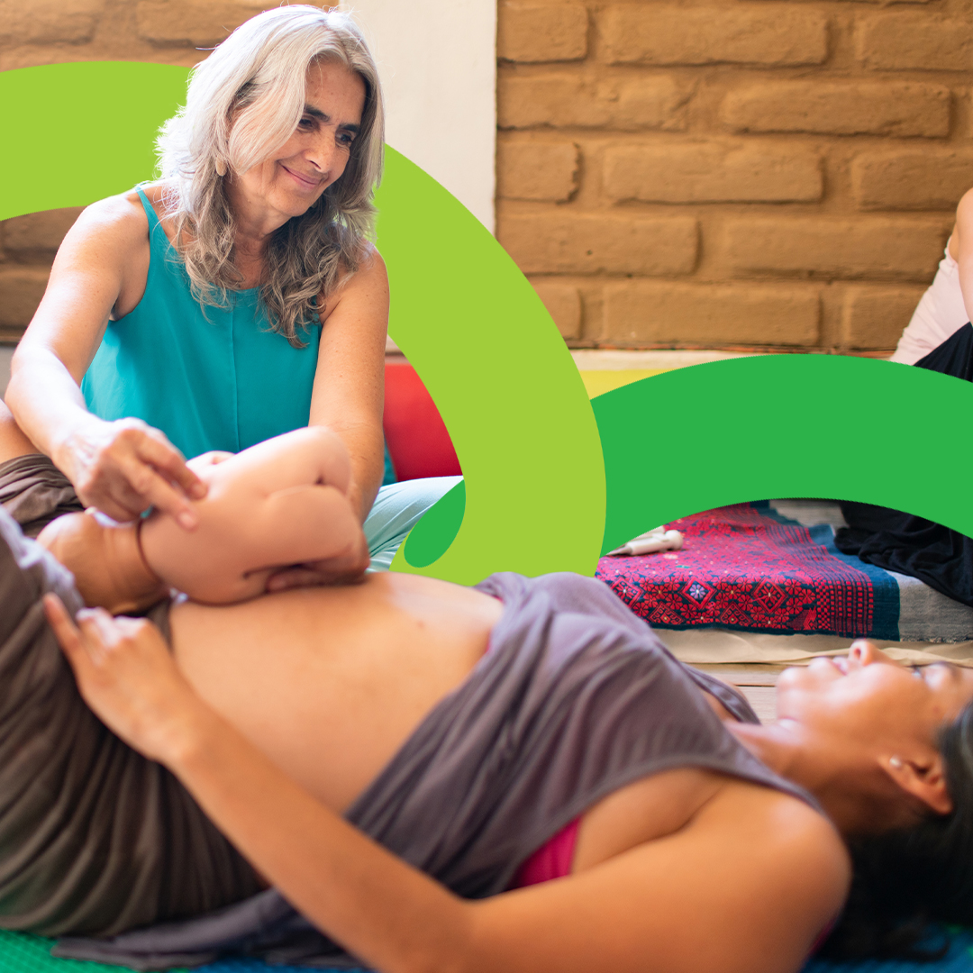

***Post 2***

**Copy**: Help your little one grow with nutritious food from WIC! What fun activities are you and your child planning this summer?

Contact your local agency today: [signupwic.com](http://www.signupwic.com/) #HealthyStartsHere

**Creative**:

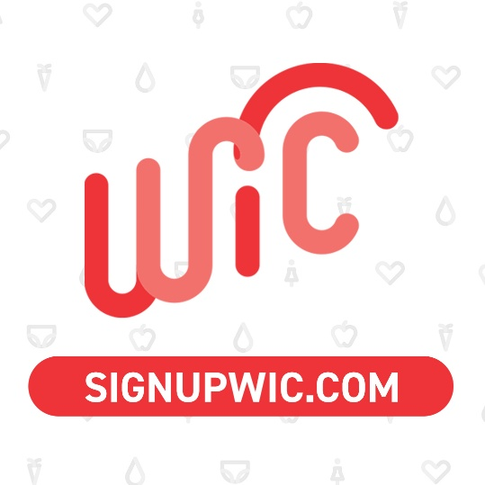

***Post 3***

**Copy**: Embarking on the incredible journey of pregnancy, childbirth, breastfeeding, and motherhood can be overwhelming. That's why WIC is here for you every step of the way.

WIC offers support through your entire journey, so you and your little one receive the care you deserve.

Visit [signupwic.com](http://www.signupwic.com/) to find a WIC agency near you! #HealthyStartsHere

**Creative**:

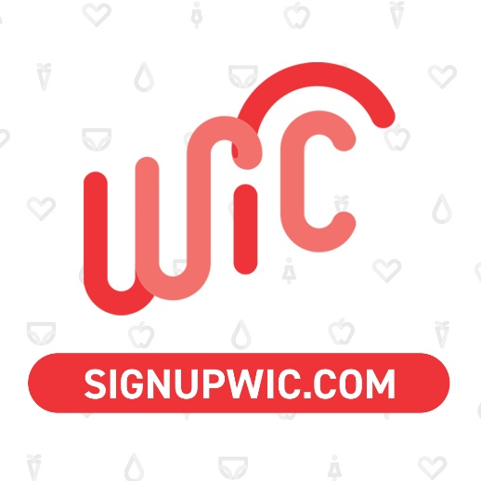

***Post 4 - will also post on WIC You Got This pages***

**Copy**: WIC is a safe space for you and your family. We offer referrals to substance use support and mental health services.

Visit [signupwic.com](http://www.signupwic.com/) to find a WIC agency near you. #HealthyStartsHere

**Creative**:



***Post 5***

**Copy**: WIC can help you fuel your summer fun! Get food from all the food groups using your WIC benefits. Contact your local WIC agency to learn which foods you can buy and where you can use your benefits.

Visit [signupwic.com](http://www.signupwic.com/) to find a WIC agency near you. #HealthyStartsHere

**Creative**:



# **Spanish National WIC Association**

**Organic Social Media Content**

**Note:** These posting dates are recommended, not required. Agencies can post on any other preferred day.

**Facebook and Instagram**

***Post 1 – July 4***

**Spanish Copy:** ¡Feliz cuatro de julio! Corta algunas rebanadas de sandía para que tú y tus pequeños se mantengan hidratados mientras disfrutan de las festividades del Dia de Independencia. 🍉

Visite [www.signupwic.com/?lang=es](http://www.signupwic.com/?lang=es) para encontrar su agencia local de WIC y solicitar los beneficios de WIC. #UnComienzoSaludableConWIC

**English Copy:** Happy fourth of July! Slice up some watermelon to help keep you and your little ones hydrated while enjoying the festivities.

Visit www.signupwic.com/?lang=en to find your local WIC agency and apply for WIC benefits. #AHealthyStartWithWIC

**Creative:**

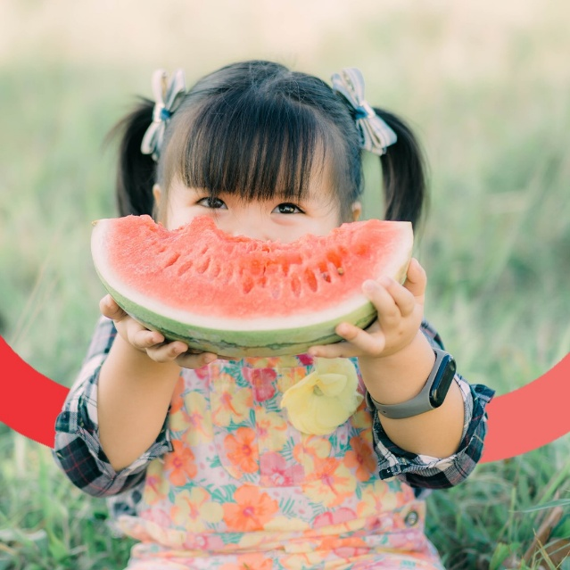

***Post 2 – July 14***

**Spanish Copy:** ¡Julio es el Mes de los Frijoles! Los frijoles son muy versátiles y contienen proteínas, fibra y hierro para fortalecer a tus pequeños. Los frijoles enlatados también están aprobados por WIC. ¿Cómo te gusta disfrutarlos? ¡Recomendamos agregarlos en su próxima carne asada!

Visite [www.signupwic.com/?lang=es](http://www.signupwic.com/?lang=es) para encontrar su agencia local de WIC y solicitar los beneficios de WIC. #UnComienzoSaludableConWIC

**English Copy:** July is Bean Month! Beans are so versatile and contain protein, fiber, and iron to strengthen your little ones. Canned beans also happen to be WIC-approved. How do you like to enjoy them? We'd recommend adding them in your next carne asada!

Visit www.signupwic.com/?lang=en to find your local WIC agency and apply for WIC benefits. #AHealthyStartWithWIC

**Creative:**

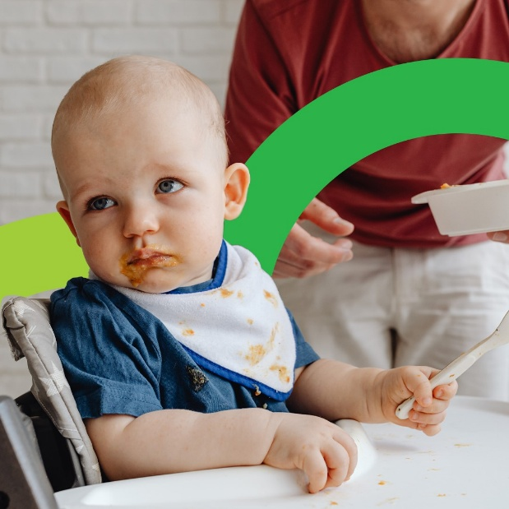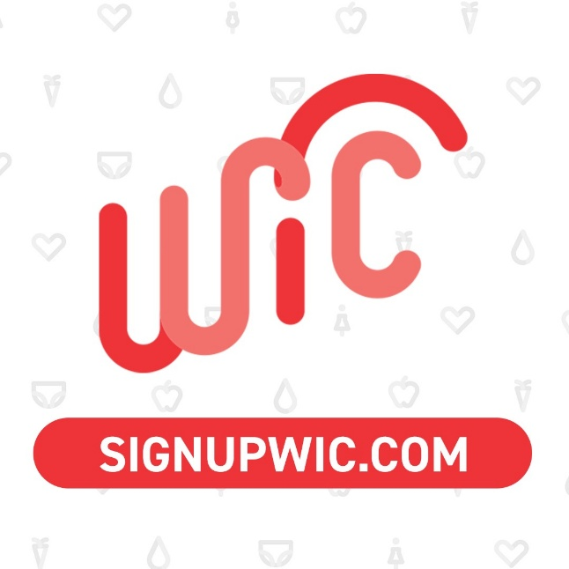

***Post 3 – July 17***

**Spanish Copy:** WIC proporciona muchos recursos y consejos sobre la lactancia, para que pueda sentirse preparada y segura cuando comience a amamantar. 🤱🏽

Mamás que amamantan, ¿qué es lo que desearían haber sabido antes de comenzar a amamantar? Comparta algunos consejos para las futuras madres en los comentarios a continuación.

Visite [www.signupwic.com/?lang=es](http://www.signupwic.com/?lang=es) para encontrar su agencia WIC local y aprender cómo presentar una solicitud. #UnComienzoSaludableConWIC

**English Copy:** WIC provides many breastfeeding resources, so you can feel prepared and confident when you begin your breastfeeding journey.

Breastfeeding moms, what is one thing you wish you would've known before starting your breastfeeding journey? Share some advice to expecting mothers in the comments below.

Visit www.signupwic.com/?lang=en to find your local WIC agency and learn how to apply. #AHealthyStartWithWIC

**Creative:**

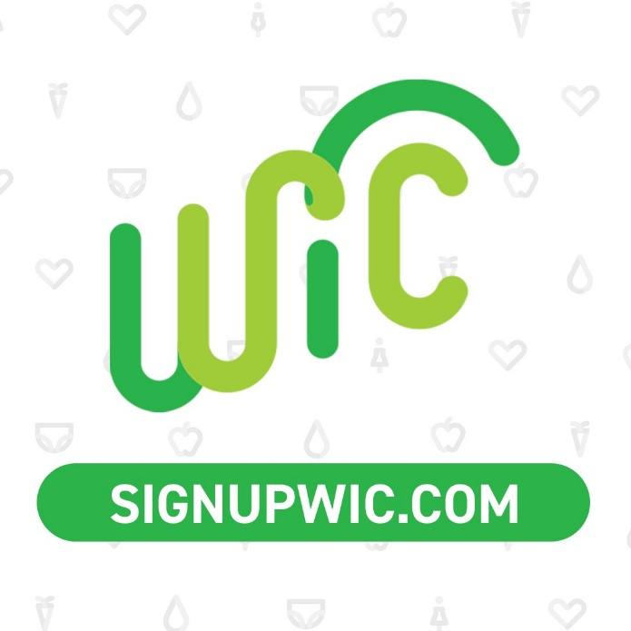

***Post 4 – July 23***

**Spanish Copy:** ¡Feliz día de los padres de familia a las mamás y papás de WIC! Cuidar de tus pequeños debe ser el viaje más gratificante y loco de la vida, pero no olvides que no estás solo. Estamos aquí para apoyarlos a lo largo del camino, ya sea brindándole orientación sobre la lactancia materna, consejos nutricionales, brindándole alimentos nutritivos complementarios o dirigiéndolos a nuestros otros servicios útiles. ¡WIC está aquí para ver triunfar a su familia! 💖

Visite [www.signupwic.com/?lang=es](http://www.signupwic.com/?lang=es) para encontrar su agencia local de WIC y solicitar los beneficios de WIC. #UnComienzoSaludableConWIC

**English Copy:**

Happy Parents Day! Taking care of your little ones must be the most rewarding and crazy journey of life, but don't forget that you are not alone. We're here to support you along the way, whether it's giving you breastfeeding guidance, nutritional advice, providing nutritious complementary foods, or directing you to our other helpful services. WIC is here to see your family succeed!

Visit www.signupwic.com/?lang=en to find your local WIC agency and apply for WIC benefits. #AHealthyStartWithWIC

**Creative:**

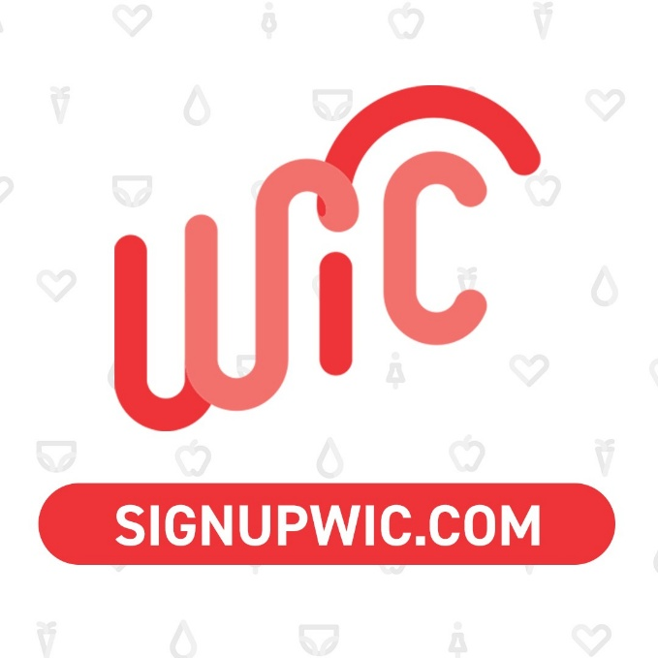

***Post 5 – July 30***

**Spanish Copy:** Queríamos tomarnos el tiempo para volver a presentarnos. Entonces, ¿qué es WIC? Somos un programa de nutrición suplementaria para mujeres, bebés y niños. Ayudamos a proporcionar alimentos complementarios, referencias de atención médica y educación nutricional para mujeres embarazadas, lactantes y posparto de bajos ingresos, y para bebés y niños de hasta 5 años que se encuentran en riesgo nutricional.

Visite [www.signupwic.com/?lang=es](http://www.signupwic.com/?lang=es) para encontrar su agencia local de WIC y solicitar los beneficios de WIC. #UnComienzoSaludableConWIC

**English Copy:** We wanted to take the time to reintroduce ourselves. So, what is WIC? We are a Supplemental Nutrition Program for Women, Infants, and Children. We help provide supplemental foods, health care referrals, and nutrition education for low-income pregnant, breastfeeding, and non-breastfeeding postpartum women, and to infants and children up to age 5 who are found to be at nutritional risk.

Visit www.signupwic.com/?lang=en to find your local WIC agency and apply for WIC benefits. #AHealthyStartWithWIC

**Creative:**

